To be completed on your company headed paper

FORMAL UNDERTAKING

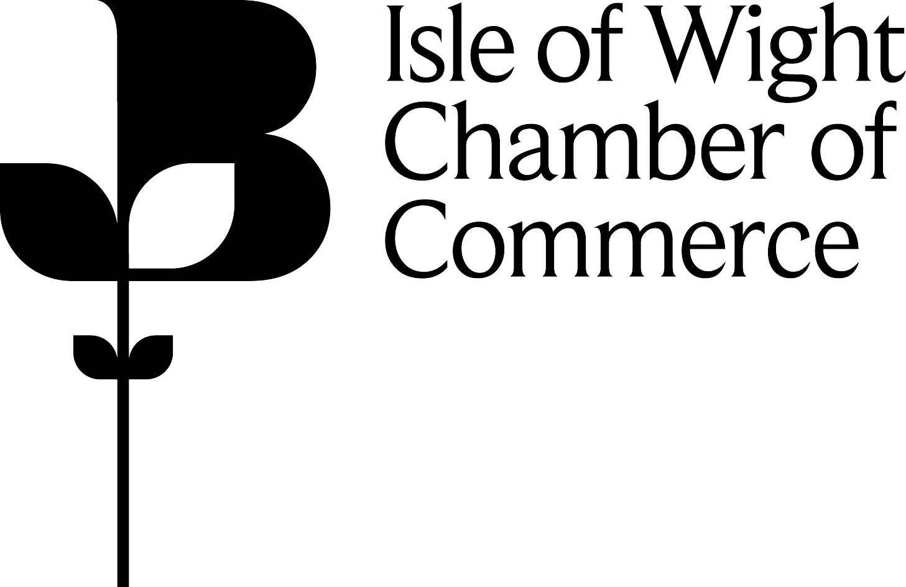
In consideration of the Isle of Wight Chamber of Commerce & Industry from time to time granting or certifying Certificate of Origin or other documents I/we hereby agree to accept and be bound by the Standard Rules for the issue of Certificates of Origin, etc in force at the time of certification, of which I/we confirm having received a copy. Further that I/we will at all times keep the issuing body and its officials indemnified against any claims or demands whatsoever which may at any time be made against them, or any of them by reason of any fault, defect, omission or inaccuracy in the content of the Certificates or other documents, or in the manner of their issue, this indemnity being subject to all statutory provisions to the contrary.

In the event of requests which stem from a legitimate enquiry from someone in possession of statutory authority e.g. Police, H M Customs & Excise or officials acting with authority of a court order, I/we hereby permit the issuing body to allow direct access, under the power of statutory authority, to such commercial information as may be required as part of the enquiry.

NB: EXPORT DOCUMENTATION CAN BE APPLIED FOR ELECTRONICALLY, WHICH SAVES YOU THE TIME AND EFFORT OF HAVING TO EITHER POST OR TAKE TO THE CHAMBER AND OR WAIT/COLLECT THEM. YOU CAN SEND AND RECEIVE YOUR EXPORT DOCUMENTATION ELECTRONICALLY. FOR MORE INFORMATION, PLEASE ASK THE DOCUMENTATION STAFF AT THE CHAMBER.

Signed ………………………………………………

Name (printed) ………………………………………………

Position ………………………………………………

(Should be Proprietor, Partner, Director
or Company Secretary.)

For and on behalf of ………………………………………

………………………………………

………………………………………

………………………………………

Date ………………………………………

